Customer Shopping Behavior Report

Project Overview
The agenda of this project is to first understand the problem statement, then analyze customer shopping behavior in detail, clean the data, and perform exploratory data analysis (EDA) and document the data-cleaning steps along with the logical thought process behind each step.

Dataset Summary
- Rows: 3,900
  - Columns: 18
  - Key Features:
    - Customer demographics (Age, Gender, Location, Subscription Status)
    - Purchase details (Item Purchased, Category, Purchase Amount, Season, Size, Color)
    - Shopping behavior (Discount Applied, Promo Code Used, Previous Purchases, Frequency of Purchases, Review Rating, Shipping Type)
  - Missing Data: 37 values in Review Rating column

Exploratory Data Analysis using Python
We began with data preparation and cleaning in Python:

- Data Loading: Imported the dataset using google collab and then used pandas for further data cleaning.

- Initial Exploration: Used df.info() to check structure and .describe() for summary statistics.
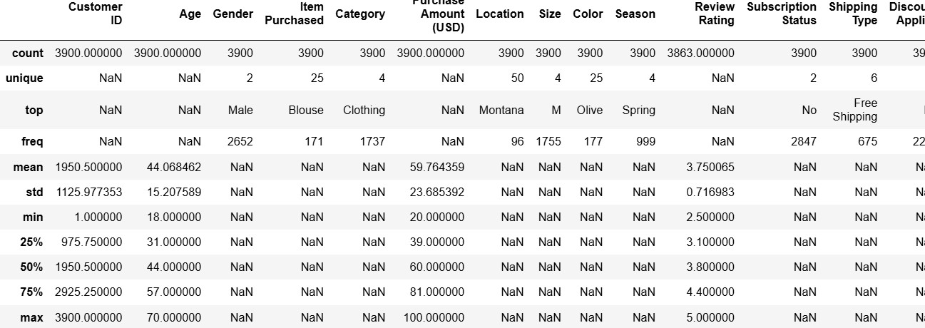

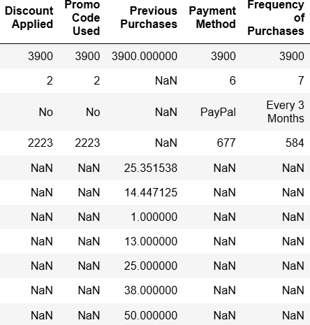

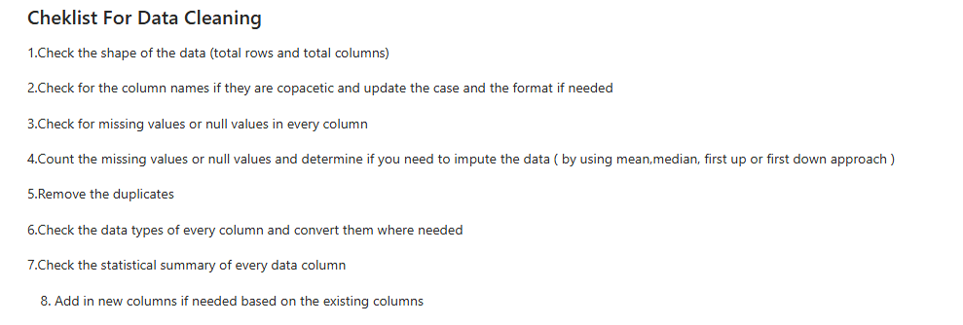

- Missing Data Handling: Checked for null values and imputed missing values in the
Review Rating column using the median rating of each product category.

- Column Standardization: Renamed columns to snake case for better readability and documentation.

Feature Engineering:

  - Created age_group column by binning customer ages.

  - Created purchase_frequency_days column from purchase data.

  - Created Customer_Type calculated column for different types of customers in Power BI

- Data Consistency Check: Verified if discount_applied and promo_code_used
were redundant; dropped promo_code_used.

- Database Integration: Imported the cleaned csv file and then changed it to xlsx format and imported the file to SSMS Customer Shopping Database for Further Querying and Analysis

Data Analysis using SQL (Business Transactions)

Customer Demographics & Revenue
How many male and female customers are there in the dataset?
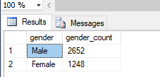
What is the total revenue generated by male vs. female customers?
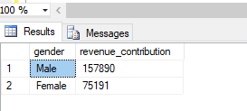
What is the revenue contribution of each age group?
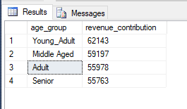
Sales Channels & Purchasing Behaviour
How many male and female customers purchased online vs. offline?
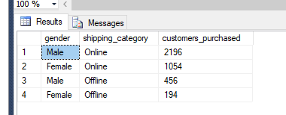
What is the purchase frequency of customers?
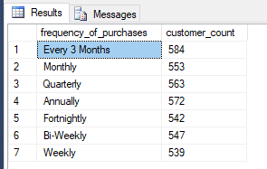
How many customers made purchases in every season?
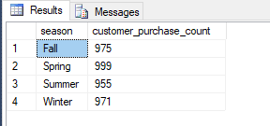
Which customers have the highest number of previous purchases (Top 5), and under which season, discount, promo code, and shipping type did they purchase?
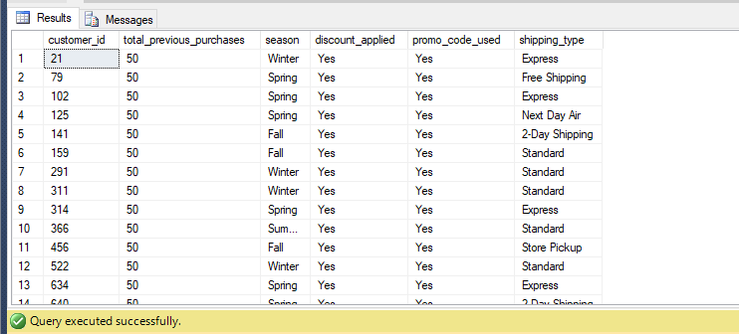
Customer Loyalty & Subscriptions
How many customers are New, Returning, and Loyal based on their number of previous purchases?
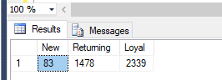

Do subscribed customers spend more than non-subscribed customers based on average spend and total revenue?
Even though the average spend is almost similar for both subscription types, non subscription users spend more than subscribed

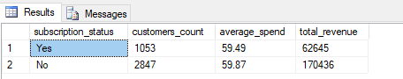

Are repeat buyers (more than 5 previous purchases) more likely to subscribe?
It is evident that most of the repeat buyers are not likely to subscribe
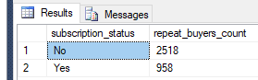

Product & Category Performance
Which product has the most reviews, and how many customers purchased it?
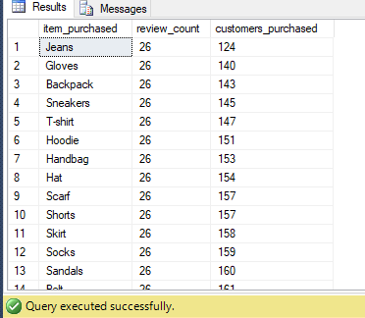
What are the top 5 products with the highest average review ratings?
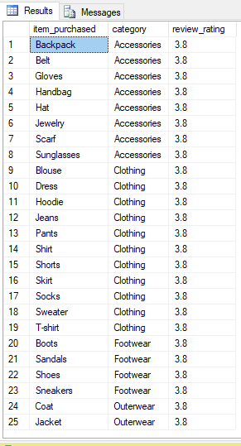
What are the top 3 most purchased products within each category?
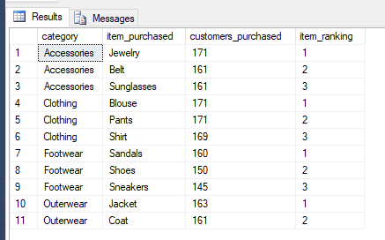

Which 5 products have the highest percentage of purchases with discounts applied?
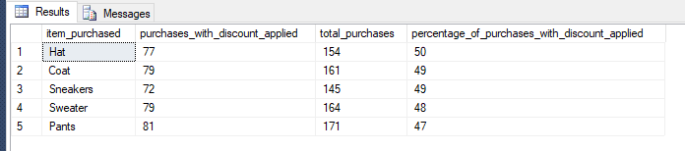
Discounts & Shipping
Which customers used a discount but still spent more than the average purchase amount?
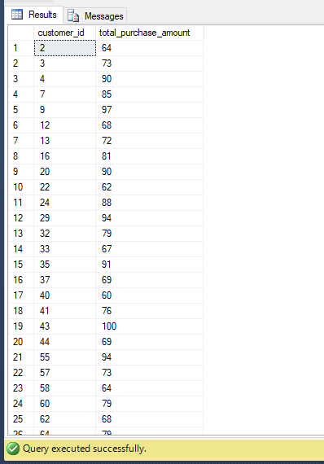
What is the average purchase amount for Standard vs. Express shipping?
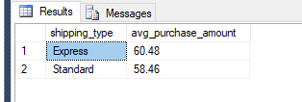

Dashboard in Power BI

Bulit an Interactive dashboard in Power BI for ease of understandability.

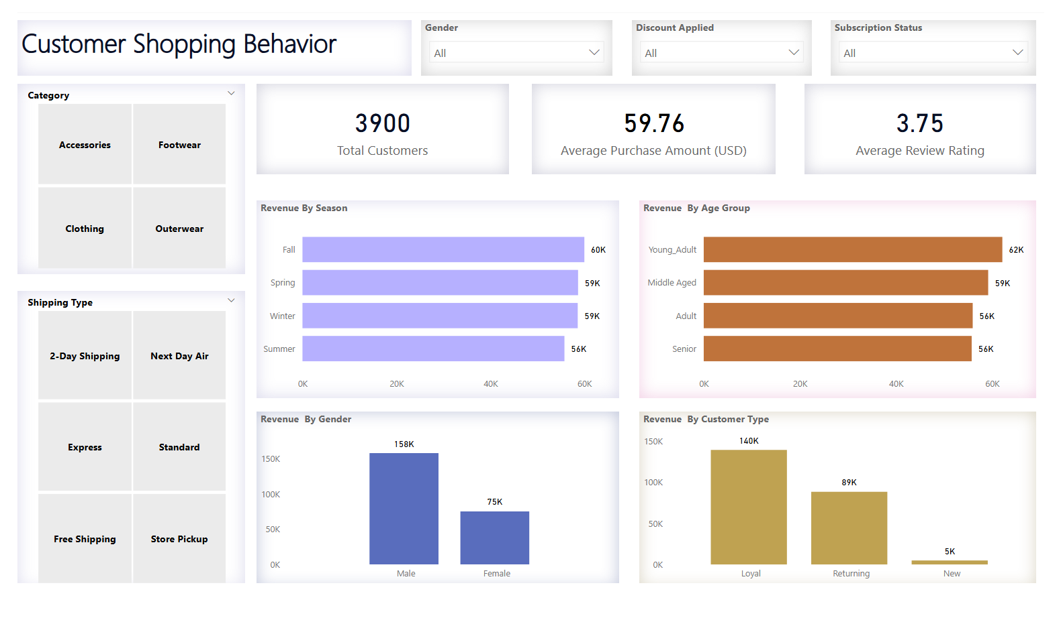

Business Observations and Recommendations

Male customers generated $157,890 in revenue compared with $75,191 from female customers. Male customers represent approximately 68% of the customer base, while females represent 32%. However, the average purchase amount is very similar for males ($59.54) and females ($60.25). This suggests that the higher revenue generated by male customers is mainly due to their larger representation in the customer base rather than significantly higher individual spending.

Business Recommendation

The company should focus on retaining its large male customer base while exploring opportunities to grow the female customer segment. Since female customers have a slightly higher average purchase amount, the company could use their product preferences and purchasing behavior to develop targeted products and marketing campaigns.

Approximately 83% of customers purchase online, while only 17% purchase offline. This shows that customers have a strong preference for online shopping.

Business Recommendation

The company should focus on strengthening its online channel by using targeted promotional offers, personalized recommendations, and discounts to increase customer engagement and encourage repeat purchases.

Subscribers and non-subscribers have almost the same average purchase amount, with subscribers spending $59.49 on average compared with $59.87 for non-subscribers. This shows that subscription status does not have a significant difference in average purchase amount in the current dataset.

Business Recommendation

The company should evaluate and improve the value offered through its subscription program by providing benefits such as exclusive offers, loyalty rewards, or personalized promotions. This could increase customer engagement and encourage more customers to subscribe.

2,339 customers (60%) are classified as loyal based on having 21–50 previous purchases, while 1,478 are returning customers and only 83 are new customers. This indicates that the company has a strong existing base of repeat and loyal customers.

Business Recommendation

The company should continue to retain its loyal customers through loyalty rewards and personalized offers while focusing on attracting new customers through new-customer promotions, introductory discounts, and targeted marketing campaigns. This could help maintain the existing customer base while increasing customer acquisition

Hats, Coats, Sneakers, Sweaters, and Pants have the highest percentage of purchases made with discounts. This shows that discounts are concentrated on these products

Business Recommendation.

The company should evaluate whether discounts are actually improving sales and revenue. If products perform well without discounts, the company can reduce unnecessary promotions and protect profit margins. If discounts are driving additional sales, they can be continued selectively.

